Student :________________________Grade___Teacher_____________
Susan Stevens Crummel, award-winning author of picture books, will be at Super Elementary on Monday, February 23. She will be making presentations to K –5 and autographing books. We will be taking orders for her books before her visit. If you wish to purchase a book, please:
- Fill out the form below and total your amount. Put form in an envelope with payment (cash or check made out to Super Elementary) and write your child’s name, teacher’s name, and AUTHOR VISIT on the front.
- Have your child bring the envelope to Ms. Librarian in the library by Friday, Feb. 5.

Name of book | How many copies? | Autograph this book to: (put the name of your child or “signature only”) | Cost each | TOTAL $
The Little Red Pen  K – 5th |  |  | $17.99 ?  Hardback (HB)
Help Me, Mr. Mutt!  K – 5th |  |  | $17.00 ? (HB)
The Great Fuzz Frenzy  K – 5th |  |  | $17.99 ? (HB)  $7.99 ? (PB)
Cook-a-Doodle-Doo!  K – 5th |  |  | $17.00 ? (HB)  $7.99 ? (PB)
And the Dish Ran Away w/the Spoon K – 5th |  |  | $17.99 ? (HB)  $7.99 ? (PB)
Jackalope  K – 5th |  |  | $17.00 ? (HB)  $7.99 ? (PB)
City Dog, Country Dog K – 5th |  |  | $7.99 ? (PB)
All in One Hour Pk-k |  |  | $6.99 ? (PB)
Ten-Gallon Bart K – 5th |  |  | $7.99 ? (PB)
Ten-Gallon Bart & WW Show K – 5th |  |  | $9.99 ? (PB)
Ten-Gallon Bart Beats the Heat K – 5th |  |  | $17.99 ? (HB)
Sherlock Bones & the Missing Cheese K – 5th |  |  | $17.99? (HB)
Find a Cow Now!  Ages 2 – 7 |  |  | $16.95 ? (HB)
My Big Dog  Ages 3 – 8 |  |  | $6.99 ? (PB)
Tumbleweed Stew  Emerging reader level 1-2 |  |  | $3.95 ? (PB)
Tumbleweed Stew/ Sopa de Matojos |  |  | $3.95 ? (PB)
Shoe Town  Emerging reader level 1-2 |  |  | $3.95 ? (PB)
 |  |  | Grand Total:
The back of this paper tells about each book. See Mrs. Crummel’s website at www.susanscrummel.com for more details.
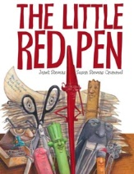
The Little Red Pen must grade the mountain of papers all by herself, as all of her school supply friends like Stapler, who has back problems, and Eraser, who has short term memory loss, won’t help. The Little Red Pen tumbles in into the trash and the zaniest rescue ensues!

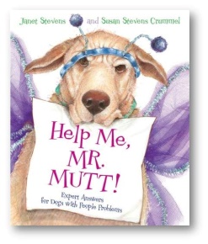
Are you a dog with people problems? Are you at the end of your leash? Don’t YELP, get HELP! Write to Mr. Mutt, Canine Counselor, for expert advice. But beware of the cat, better known as THE QUEEN!
NYT Bestseller, one of Time Magazine’s Top 10 Children’s Books of 2008, Winner of
the 2010 Texas Bluebonnet Award

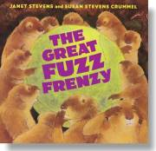
Violet, a golden retriever, drops a tennis ball down a prairie dog hole and starts a fuzz frenzy—or is it a fuzz fiasco? Those prairie dogs grab that fuzz and create outlandish outfits. But what happens when the fuzz runs out?
NY Times Bestseller and winner of several state book awards

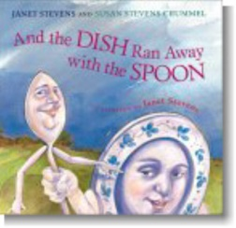

What would happen if the dish ran away with the spoon and never came back? This is the untold tale of their disappearance and Dog, Cat, and Cow's quest to bring them back.
Child Magazine Book of the Year ALA Notable Book

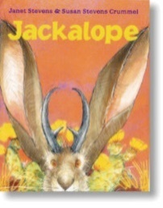
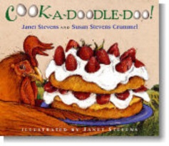
“Cook-a-doodle-doo!" crows Big Brown Rooster. Soon Rooster and his eager assistants--Turtle, Iguana, and Potbellied Pig--set out to make the most wonderful, magnificent strawberry shortcake in the whole wide world.
Winner of the 2001 Texas Bluebonnet Award
An unhappy jackrabbit is granted horns by his fairy godrabbit, but the trouble those horns bring--hooooo-wee! It sure makes for a hare-raising tale. IRA Children’s Choice Award

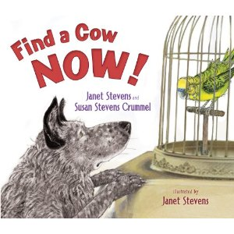
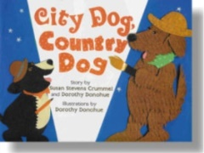
The Dell’s stinky scrumptious cheese is missing! Sherlock Bones to the rescue! He can solve any mystery by using his senses—he’s a sensible hound! Or Is it a GIANT problem?

Dog was born to herd cows. Ruff! Ruff! Yip! Yip! Yeehaw! Only problem is, he’s never seen a cow! Does he find one? Well . . .

Vincent van Dog is from the country and Henri T. LaPooch is from the city. They meet at art school and become friends--very DIFFERENT friends! Featured at the National Gallery of Art in Washington, D.C. 2006
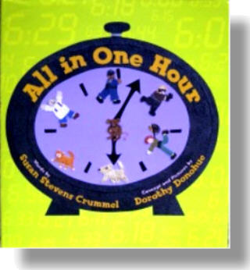
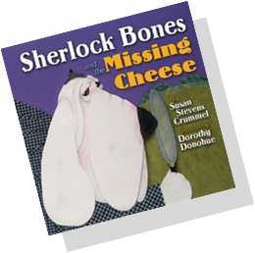
“This is the cat. What happens now? She sees the mouse. Meow, meow! She chases the mouse that started it all."
Soon a dog, a dogcatcher, a bank robber, a policeman, and a grocer join in a wild chase
that takes place all in one hour!

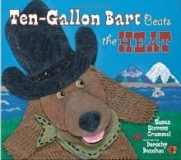
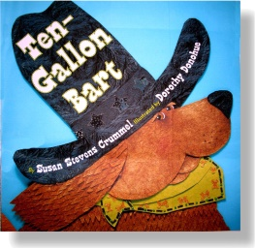
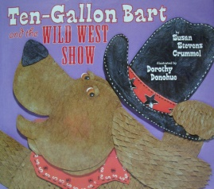
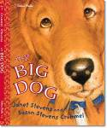
Ten-Gallon Bart journeys to Alaska to Beat the Heat in Dog City!
Ten-Gallon Bart is fixin’ to retire as sheriff. Billy the Kid is comin’ on the noon train to eat the town!

Ten-Gallon Bart rides Crazy Bull so he can be the star of Buffalo Chip’s Wild West Show!
My name is Merl and I am a cat. A very special cat. My people wouldn’t dream of bringing a PUPPY into my purr-r-r-fect house. But they do Merl runs away-- only to find that there's no place like home.

