Janet Stevens and Susan Stevens Crummel, creators of many award-winning picture books, will be at Super Elementary on Monday, February 23. They will be making presentations to K –5 and autographing books. We will be taking orders for their books before the visit. If you wish to purchase a book, please:
- Fill out the form below and total your amount
- Put form in an envelope with payment (cash or check made out to Super Elementary) and write child’s name, teacher’s name, and AUTHOR VISIT on front.
- Have your child bring the envelope to Ms. Librarian in the library by Friday, Feb. 5.

Student :________________________Grade___Teacher_____________
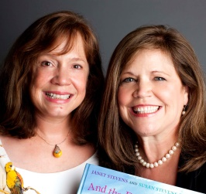

Name of book | Autograph to: (put the name of your child or put “signature only”) | Cost each | How many copies? | TOTAL $
The Little Red Pen  K – 5th |  | $17.99 ?  Hardback (HB)
Help Me, Mr. Mutt!  K – 5th |  | $17.99 ? (HB)  $7.99 ? (PB)
The Great Fuzz Frenzy  K – 5th |  | $17.99 ? (HB)  $7.99 ? (PB)
Cook-a-Doodle-Doo!  K – 5th |  | $17.00 ? (HB)  $7.99 ? (PB)
And the Dish Ran Away w/the Spoon  K – 5th |  | $17.99 ? (HB)  $7.99 ? (PB)
Jackalope  K – 5th |  | $17.00 ? (HB)  $7.99 ? (PB)
Find a Cow Now!  Ages 2 – 7 |  | $16.95 ?  Hardback (HB)
My Big Dog Ages 3 – 8 |  | $6.99 ?  Paperback (PB)
Tumbleweed Stew  Emerging reader level 1-2 |  | $3.95 ?  Paperback (PB)
Tumbleweed Stew/ Sopa de Matojos |  | $3.95 ?  Paperback (PB)
Shoe Town  Emerging reader level 1-2 |  | $3.95 ?  Paperback (PB)
You can also offer books they did separately:
Wild About Us!  Tops & Bottoms  To Market To Market  Epossumondas series Anansi series | ←Janet
Ten-Gallon Bart series  Sherlock Bones and the Missing Cheese | ←Susan
Grand Total:
The back of this paper tells about each book. See their websites at
www.janetstevens.com or www.susanscrummel.com for more details.

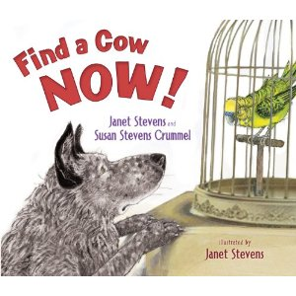

Dog was born to herd cows. Ruff! Ruff! Yip! Yip! Yeehaw! Only problem is, he’s never seen a cow! Dog leaves the city and heads to the country to find a cow. Does he find one? Well . . .

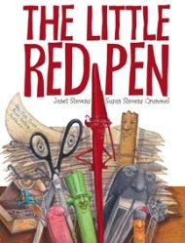

The Little Red Pen must grade the mountain of papers all by herself, as all of her school supply friends like Stapler, who has back problems, and Eraser, who has short term memory loss, won’t help. The Little Red Pen tumbles in into the trash and the zaniest rescue ensues!
New title as of April 2011!!!

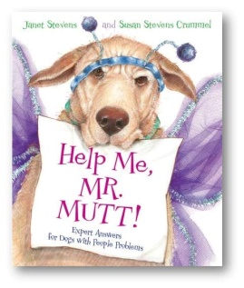
Are you a dog with people problems? Are you at the end of your leash? Don’t YELP, get HELP! Write to Mr. Mutt, Canine Counselor, for expert advice. But beware of the cat, better known as THE QUEEN!
NYT Bestseller, one of Time Magazine’s Top 10 Children’s Books of 2008, Winner of the 2010 Texas Bluebonnet Award

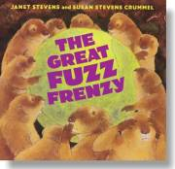

Violet, a golden retriever, drops a tennis ball down a prairie dog hole and starts a fuzz frenzy—or is it a fuzz fiasco? Those prairie dogs grab that fuzz and create outlandish outfits. But what happens when the fuzz runs out?
NY Times Bestseller and winner of several state book awards

“Cook-a-doodle-doo!" crows Big Brown Rooster. "Let's get cooking!" So Rooster and his eager assistants--Turtle, Iguana, and Potbellied Pig--set out to make the most wonderful, magnificent strawberry shortcake in the whole wide world.
Winner of the 2001 Texas Bluebonnet Award
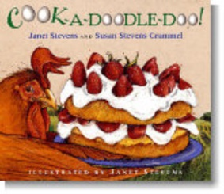

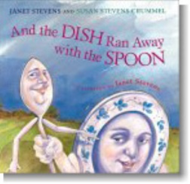

What would happen if the dish ran away with the spoon and never came back? This is the untold tale of their disappearance and Dog, Cat, and Cow's quest to bring them back.
Child Magazine Book of the Year ALA Notable Book

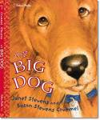
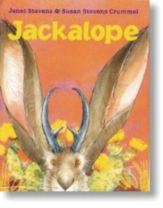
My name is Merl and I am a cat. A very special cat. My people wouldn’t dream of bringing a PUPPY into my purr-r-r-fect house. But they do! Merl runs away-- only to find that there's no place like home.
Never seen a jackalope? Not even sure what it is? First he was a plain old hare. You know, a jackrabbit. The horns came later, along with a corny fairy godrabbit and a cranky coyote. The trouble those horns brought--hooooo-wee! It sure makes for a hare-raising tale!
IRA Children’s Choice Award

